Name: _______________________

American Computer Science League

Boolean Algebra Practice Round
Answers must be left in this column

Short Problems

- Boolean Algebra
Assuming that 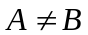, simplify the following Boolean Algebra
expressions as much as possible:

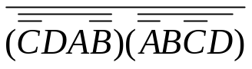

- Boolean Algebra
Write the simplest Boolean Algebra expression for which
(0,0,1,1), (0,0,1,0), (0,1,0,0), (1,1,0,0), (1,0,1,1), and (1,0,1,0) are
the only solutions.

- Boolean Algebra
List all of the following that are equivalent to: 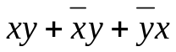

1) xy
2) 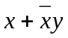
3) x+y
4) 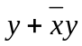
5) x
6) 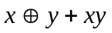

KEY

1. CD (after DeMorganiz-ing you get 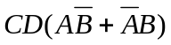

2. 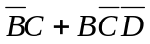

3. 2, 3, 6

